Lab5: Data Visualization

Student Number: 041067235
Student Name: Andrianna Wardill
Using lab5.ipynb file answer all the Questions mentioned in the notebook. Submit the word document with all the screenshots (showing your name, code, Markdown) and answer to each question

Sample Output:
Q1. What type of Correlation do you see from the above Scatter plot?
Sample Output:
First Show your Notebook Code with your name
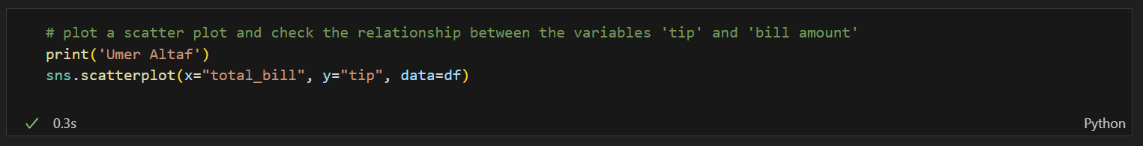

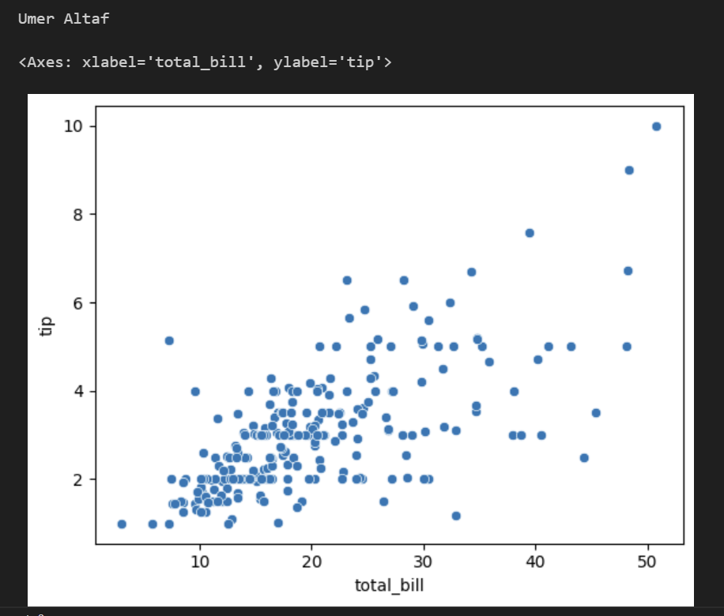
Answer to Question:
Q1.
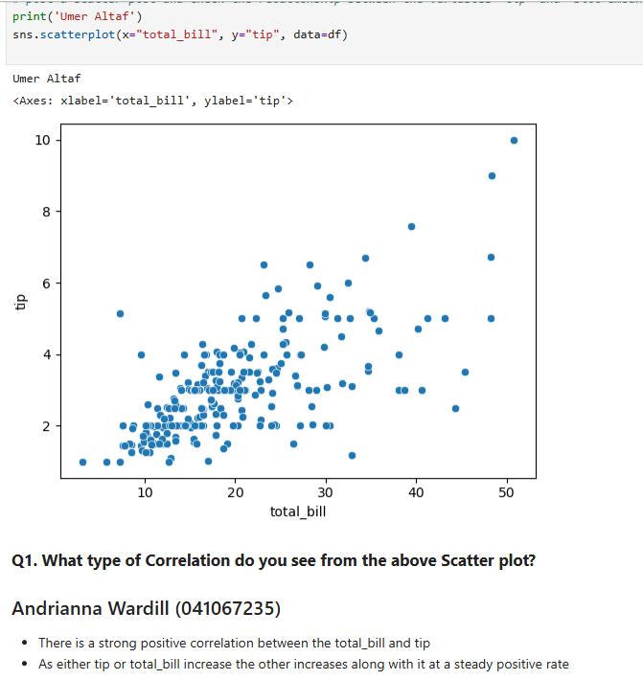
Q2.
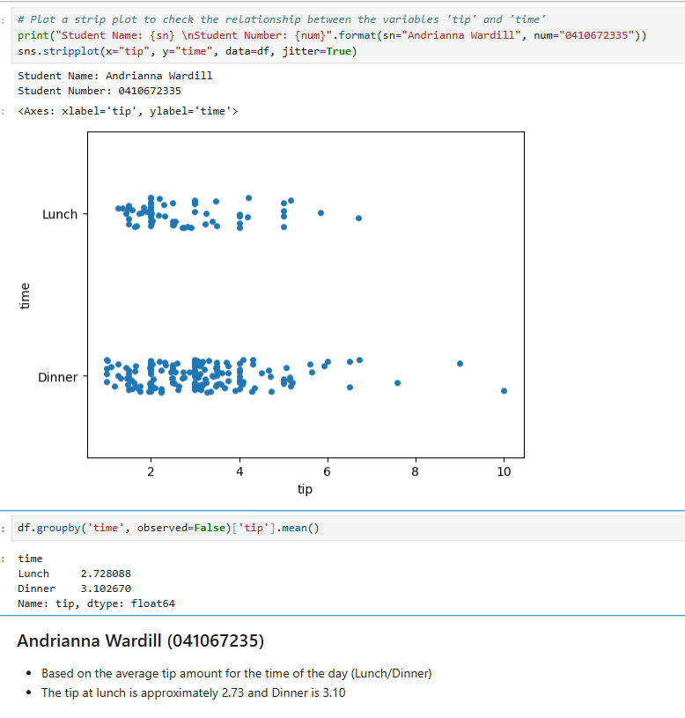
Q3.
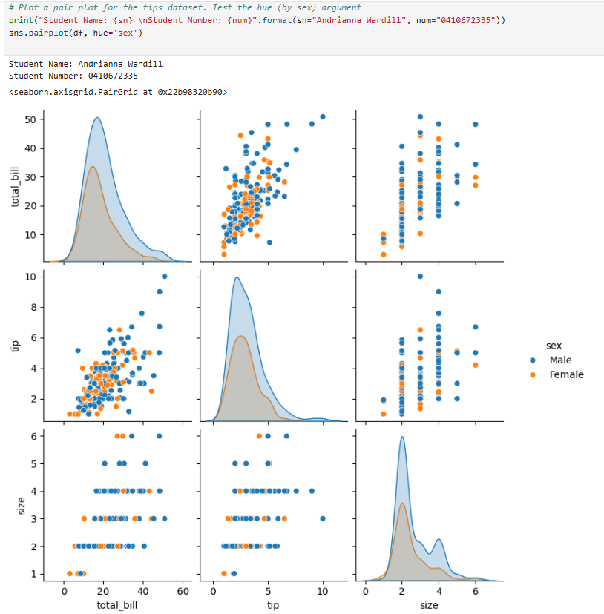
Q4.
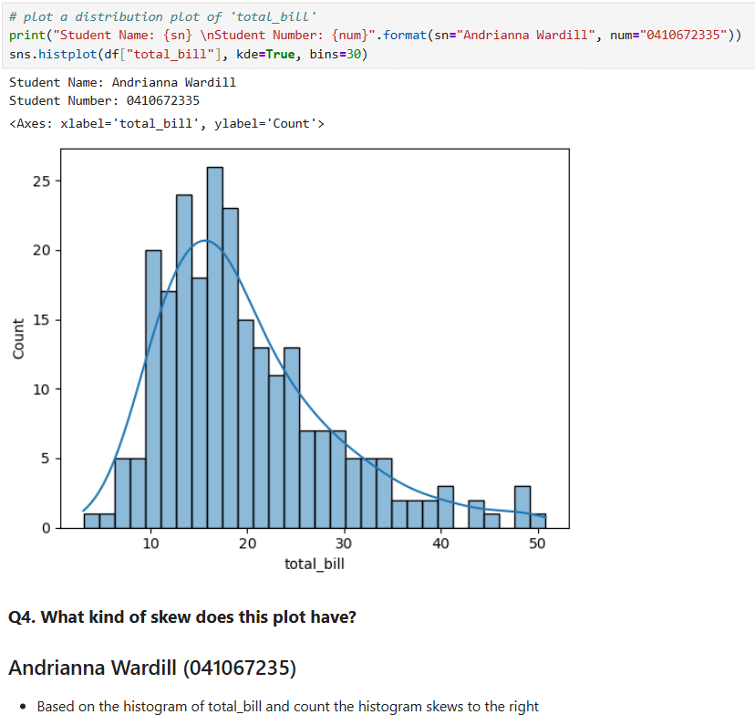
Q5.
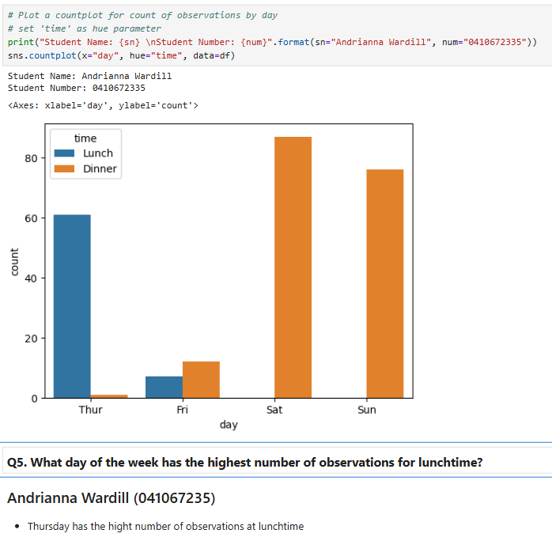
Q6.
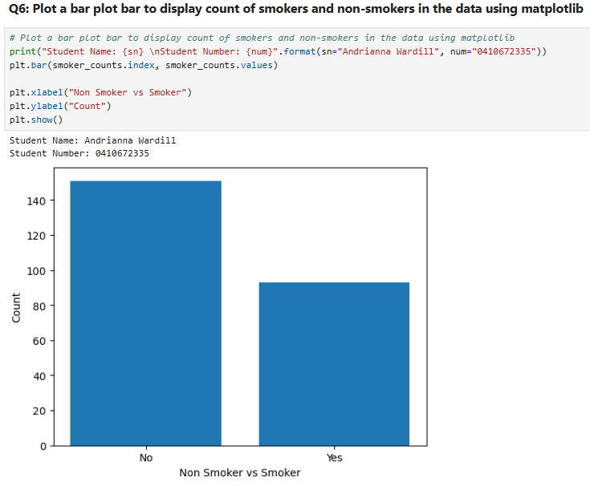
Q7.
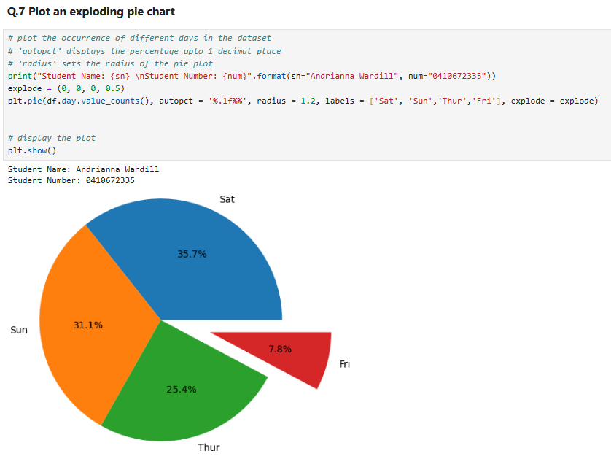
Q8.
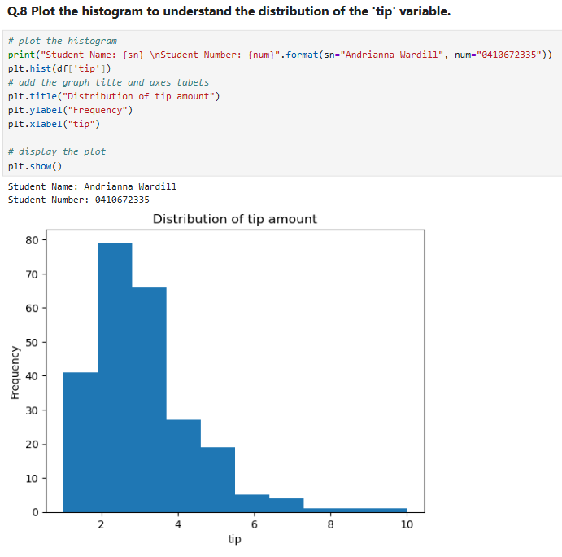
Q9.
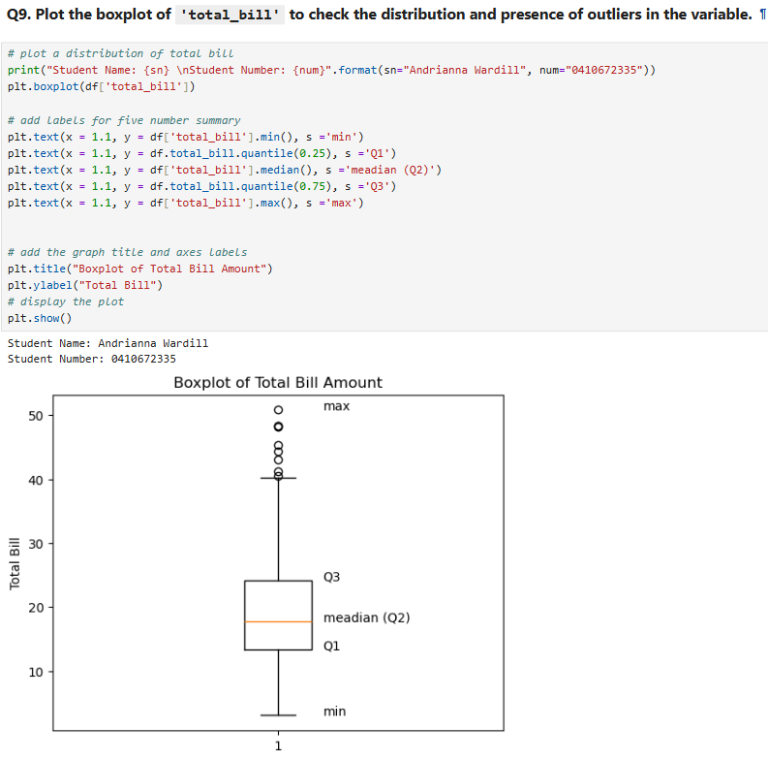
Q10.
